Saturday, December 18, 2010

James Peterson RIP
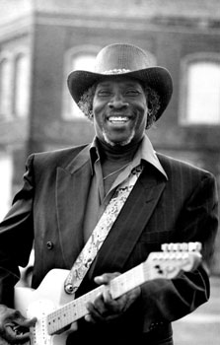
From Bob Corritore
- RIP James Peterson, November 4, 1937 - December 11, 2010 This sad news just in from Selby Minner. Tampa based, Alabama born singer/guitarist James Peterson died Saturday of a heart attack. He was 73. James was a stirring performer with an amazing voice, a powerful guitar style, as well as being a clever songwriter. James has numerous CDs to his credit, on labels such as Waldoxy/Malaco, Ichiban, Perception, and Hown Dog. James is also the father of the gifted Lucky Peterson. For an article on James' passing, click here. For a nice bio of James Peterson, click here. Another great one from the older generation of bluesmen is gone. Prayers to Lucky and to the Tampa blues community as well as all of James Peterson's many fans.

