UP TO DATE LINEUP
RENTIESVILLE
DUSK TIL DAWN BLUES FESTIVAL 2015

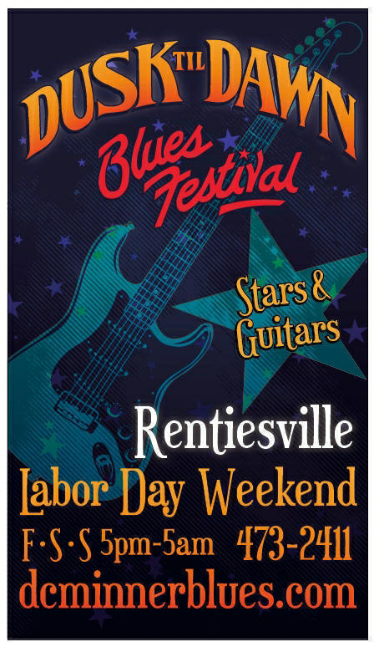
FRIDAY, September 4th 2015 Blues Fest
MAIN STAGE Fri Sept 4
4:00 pm Gates open; Happy Hour
between sets: Harold Aldridge, OBHOF – Taft and Tahlequah
6:00 Selby Minner, OBHOF and
Dan Oklahoma Slim Blues on the Move
7:15 Jus Sayin
8:30 Oklahoma Ollie
9:45 Johnny Rawls – Blues Foundation
Soul Blues Artist of the Year MS
11 Layce Baker Jr. And Black Diamond
– California, Oklahoma, OBHOF
contact Selby 918 855 0978
www.dcminnerblues.com
BACK PORCH STAGE Fri Sept 4
6:00 Mike LaFever - Tulsa
7:15 The ROXY Spotlighters from Muskogee - Spotlight on Young Talent Group
8:30 Roger Hurricane Wilson
9:45 Spa City Blues Society, Blues in the Schools group
11 p.m. Ron Hubbard (formerly w Miss Blues)
BLUES CLUB STAGE indoors Fri Sept 4
7:15 Harry and Debbie Blackwell both OBHOF - Dunsmuir CA
8:30 Bat-Or Kalo - Israel
9:45 INDOOR INVITATIONAL JAM with Debbie Blackwell, more
MIDNIGHT Selby Minner
AFTER HOURS: Johnny Rawls, Layce Baker Jr. and Black Diamond

SATURDAY SEPTEMBER 5th 2015 Blues Fest at D.C. Minner's

MAIN STAGE Sat Sept 5th
4:00pm Gates open; Happy Hour
between sets: Eric Walker OKC and with Bonnie McCoy sometimes
6:00 Checotah H School Rt 66 Big Band with
Roger Hurricane Wilson OBHOF and Jim Davis OBHOF
7:15 Selby Minner band w Okla Slim, Cecil Gray OBHOF also Little Miss
Peggy OBHOF
8:30 Miss Blues OBHOF Texas and OKC
9:45 Lil Jimmy Reed, coming in from Europe and AL
10:30 Johnny Rawls – Blues Foundation Soul Blues Artist of the Year from MS
11:45 Direct Connect OKC
BACK PORCH STAGE Sat September 5th
6:00 Dylan Whitney Band
7:15 Bonnie McCoy – great neice of Memphis Minnie here from Kansas City
8:30 Mama Cookie
9:45 Kit Love Robertson Anarchy Blues
11 Big MaClyde Sheeley Wichita KS
12 Cowboy, Bronko, - Checotah and Big Dave Carr Jr (sax) - Dallas
BLUES CLUB STAGE indoors Sat Sept 5th
5:00 Dues Paid – Bartlesville with Wolf Man Black OBHOF
7:15 Sunsetter - OKC
8:30 Cecil Gray and Band
9:45 INDOOR JAM with Debbie Blackwell and Berry Harris, Mama Cookie,
Sunsetter, Little Miss Peggy and more
MIDNIGHT Selby Minner
AFTER HOURS: Lil Jimmy Reed, Layce Baker Jr., Johnny Rawls and Miss Blues
^{all acts subject to change}

SUNDAY SEPTEMBER 6th 2015 Blues Fest at D.C. Minner's

MAIN STAGE Sun Sept 6th
4:00pm Gates open; Happy Hour
between sets: Roger Hurricane Wilson OBHOF, GA and w Bonnie McCoy sometimes
6:00 GOSPEL including Rev. Harper of Eufaula and Rev Tony Wise's VOPBC Men's Chorus
7:15 Wanda Watson
8:30 Selby Minner Dan Oklahoma Slim and Steve Shrum
9:45 Larry Garner Baton Rouge Louisianna. International, here for 2nd time
11 Johnny Rawls – Blues Foundation Soul Blues Artist of the Year from Mississippi

BACK PORCH STAGE Sun Sept 6th
7:15 Piano Man
8:30 Last Call
9:45 Baby Ray Mucker OBHOF – Pittsburg CA, McAlester
11 Magic Mike Updegrove
12 Dangerous GentlemenZ
BLUES CLUB STAGE indoors Sun Sept 6th
6:00 Brothers Dupree with Sista Sarah Wade - Lawton OK
7:15 Berry Harris – OBHOF - Stringtown OK and Wichita KS
8:30 Jimmy Preacher Ellis - OBHOF – Seattle, Tulsa, now Dallas
9:45 INDOOR INVITATIONAL JAM
with Debbie Blackwell and Cecil Gray, Jimmy Ellis, Berry Harris and
MIDNIGHT Selby and Band, Bonnie McCoy
AFTER HOURS til 5am Larry Garner Band, Baby Ray Mucker, Johnny Rawls with Harry Blackwell and more!

NEW THIS YEAR
WORKSHOPS all week from some of our best times TBA
Technology – check him out Roger Hurricane Wilson bring him your questions!!
web, social media and digital recording INFO
Debbie Blackwell how to make your own CDs
Harold Aldridge where did the blues com from?
Bonnie McCoy The Memphis Minnie & Big Joe Wms connection
SPECIAL CD Project funded by the OAC – Checotah High School's Rt 66 Big Band headed by Jim Davis OBHOF and Roger Hurricane Wilson OBHOF. Roger will come in from GA and record a blues/jazz CD with the students during the week of the festival!
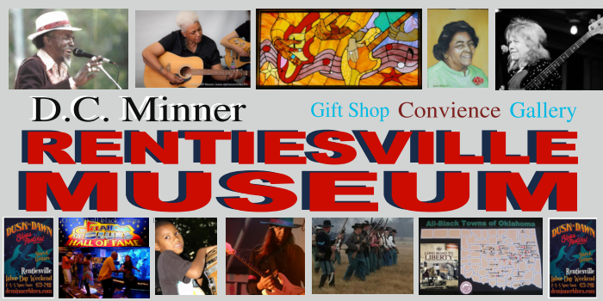
AND Volunteer Sponsor Party Under the Tent THURSDAY nite with Danny Timms 7 – 9 Sept 3 –
as a thank you to Sponsors and the '10 + hour pre-fest volunteers'
It takes a lot to do a Blues Festival
– come HELP early, meet people, and start the night BeFoRe!
D.C. Minner Rentiesville MUSEUM –Opened recently!! and the Honey Springs Visitor and Research Center across the street to the NE is now under construction!

NEW ON THE FEST
Bat – Or Kalo, Spa City BITS Band, Lil Jimmy Reed, Brothers Dupree with Sista Wade, Anarchy Blues, Jus Sayin, Mike LaFavor, Roxy Spotlight, Dirty Red and the Soul Shakers, Magic Mike Updegrove, Dylan Whitney BAND, Mama Cookie...more!

