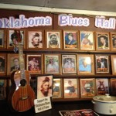
PRESS RELEASE (918) 855-0978
Rentiesville Dusk til Dawn Blues Festival - 27th Annual!
Oklahoma Blues Hall of Fame F.O. R. Blues Inc. www.dcminnerblues.co/about selbyminner@gmail.com
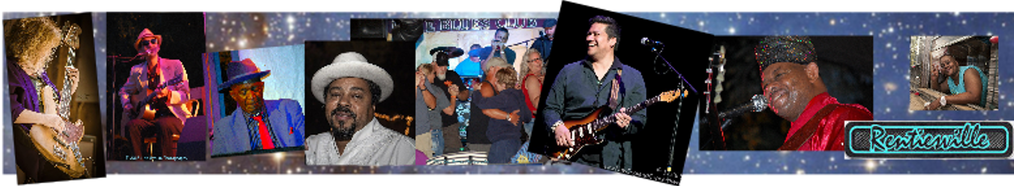
September 1, 2, 3 FRI SAT SUN of Labor Day Weekend; 5 pm til 5 am, $15; under 12 free
Selby Eric Little Brother Walker Leon Blue Kenny Diggs d'Elegantz dancers & Last Call Mato Indigenous, Lil ED Blues Imperials Sharon at the gate
Saturday night last year broke right out into a great big party! Full house, good vibes!
Down Home Blues Oklahoma Style 200 musicians; 30 bands on 3 stages;
a showcase of regional OK blues and 4 international headliners
Mark your calendar for Labor Day Weekend and come to the longest running big blues fest in Oklahoma
RENTIESVILLE is…: 15 m, S of Muskogee, 125 m, E of OKC, 200 m. N of Dallas & 70 m SE of Tulsa I – 40 @ US 69 www.dcminnerblues.com selbyminner@gmail.com Info (918)855-0978
face book Rentiesville Dusk til Dawn Blues Festival . . or. . OBHOF . . or . . Selby Minner
HEADLINERS INCLUDE:
INDIGENOUS – Mato back in Rentiesville after some 20 years...he has grown into one of the most respected singer guitarists on the road, touring regularly with Buddy Guy and the Jimi Hendrix Experience – brought to you in large part by the Checotah and the Eufaula Creek Nation Casinos!
LIL' ED and the Blues Imperials – band of the year Award from Memphis Blues Foundation – same players for 20 years – a powerhouse of FUN!
NORMAN JACKSON BAND– placed third in the I B C Challenge, over close to 2000 bands!
JOHNNY RAWLS keeping the Mississippi Blues alive and on the road non stop for years.
AKEEM KEMP from Arkansas – placed in the IBC Youth Challenge in Memphis
SELBY MINNER and Blues on the Move – Oklahoma Slim
BONNIE McCoy niece of the late great Memphis Minnie!!
CAPTAIN JACK up from the Dallas area DUES PAID Bartlesville OBHOF
MISS BLUES the real deal, say no more! FUN! OBHOF
LEON ROLLERSON a legend from Tulsa OBHOF
JIMMY Preacher ELLIS – up from Dallas, everyone loves Preacher OBHOF
BERRY HARRIS – from Stringtown OK and Wichita… a life in the blues OBHOF
HAROLD JEFFERSON OKC, OBHOF MAIN McMANN Wichita KS
WANDA WATSON Tulsa OBHOF OKLA OLLIE will be inducted during his set
CeCe, SUNSETTER from OKC, Harley COWBOY Hamm (Checotah), Roger HURRICANE Wilson (GA) OBHOF, Jerome Robinson FL, . . . 10 + Oklahoma Blues Hall of Famers on the show
The Kid’s Village (“children under 12 are free and we keep them busy having fun while the music soaks in!” OK State Arts Council roster artists and funding through a series of grants has helped keep the festival alive over these 21 years. Kid’s Village would not be complete without Joann McMillan and her stick puppets (which require lots of little hands to make them dance across the field) and Patrick Riley

. . “World’s best - and largest - back yard party!” “This is peace as the world should know it!”. . . A blues festival that is truly unique as it is a family event with lots for children to do – but not after midnight in the old Juke Joint – adults only, please! “You can see all the headliners by 10:30 pm but night owls keep on and dig the blues from 5 pm til 5 am.” - chosen by UniqBeauties.com as one of the WORLD's 10 Awesome Festivals!!
Created by D.C. Minner himself with, and now presented by, Selby Minner and the Friends of Rentiesville Blues Inc., the old cotton field out back will ring with the blues!! D.C. (1935-2008, in 7 Halls of Fame) knew they were bulldozing old juke joints every day and has kept his family legacy alive here in Rentiesville, where he was born and raised, for people to enjoy from now on. . . . Kids are free, we keep them busy. The High School Jazz Band will come in courtesy of Jim Davis. And there is a Gospel Show to start the Festivities on Sunday. The outdoor part is the most family friendly Blues festival you will find. But adults only in the juke joint, please. All the headliners from the main outdoor stage come inside after midnight and perform their second sets.
Years of People having FUN: Founding board member D Lovera puts it this way – “Hey Everybody! Tell Everybody!...” that in Oklahoma, hidden out in the woods is a little old juke joint called the Down Home Blues Club, It’s authentic, funky, and very much alive.
It’s been there since Oklahoma Bluesman D.C. Minner’s grandmother Lura opened up the Cozy Corner, a bootleg corn whiskey bar in 1936. Now, however, the bootleg whiskey is gone. You can get a cold beer or a soda, and sometimes people bring potluck, but it’s all about the music. The club hosts a free jam session party every Sunday, musicians show up to play, and the years roll back. Part of the magic is in the music played there, but the room itself has a grittiness and authenticity both palpable and intoxicating. It is rural and real in a sense that other venues fail to capture. D.C. built it with his own hands... you can feel it. For those who long to feel the power of the Blues, try Rentiesville!”
# Rentiesville Road Trip google OBHOF
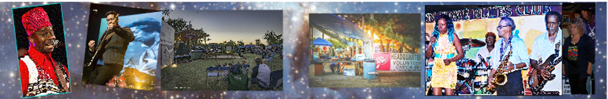

Keeping Keeping Oklahoma Blues Alive
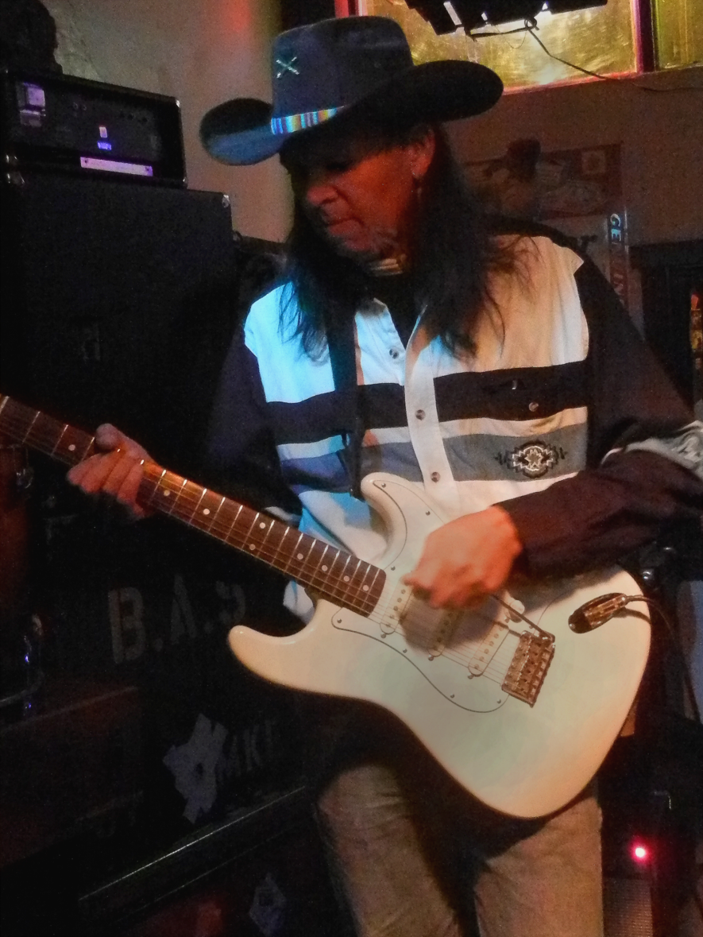
Filed by Michael Cross in Art & Life, Feature, Local News, News.
The Blues: When most people hear it they think of Memphis or Chicago or New Orleans even Kansas City.
But, there’s a resurgence of the blues in Oklahoma focusing on the present as well as the past.
Just off I-40 and Highway 69 north of Checotah sits the small town of Rentiesville.
The historic black town of just 99 people includes the Oklahoma Blues Hall of Fame in an old bar which originallyopened in 1936.
The current owner Selby MInner gives us a tour of the place originally opened by the grandmother of blues great D.C. Minner, Selby’s husband.
A display on one wall holds pictures of the 100 inductees to the Hall of Fame over the past 13 years.
Although D.C. died in 2008, Selby has kept the hall of fame going as well as the annual Dusk till Dawn Festival which has been around since 1991 during Labor Day Weekend.
Oklahoma blues musicians have played with legends like Count Bassie, Duke Ellington, Louis Armstrong, Cab Calloway and Billie Holliday.
And many Oklahomans have become legends themselves like Charlie Christian, Jimmy Rushing, Jimmy Liggins, Lowell Fulson, Roy Milton, Elvin Bishop, and Jimmy 'Chank' Nolen, with James Brown 30 years.
In fact, Oklahoma City musician and band leader Hart Wand published the first blues song on Sheet music called “Dallas Blues”.
At her home in Oklahoma City, Dorothy Ellis also known as Miss Blues plays a version of it on her computer.
For 70 years Miss Blues has performed what she calls a style of music unique to America and Oklahoma.
“I think that we should celebrate just because it’s there and it’s the one thing that we can call our own in America. What else we got that nobody else’s hand hasn’t been in.”
Miss Blues started singing the Blues when she was eight years old and has always believed it started in Oklahoma.
She was inducted into the Hall of Fame in Rentiesville back in 2004.
She says she loves the fact that the hall of fame is in an old drinking establishment.
“It’s in a juke joint,” she laughs. “Everybody else got a real pretty place. We got this juke joint and it’s housed in where the blues started in a juke joint.”

