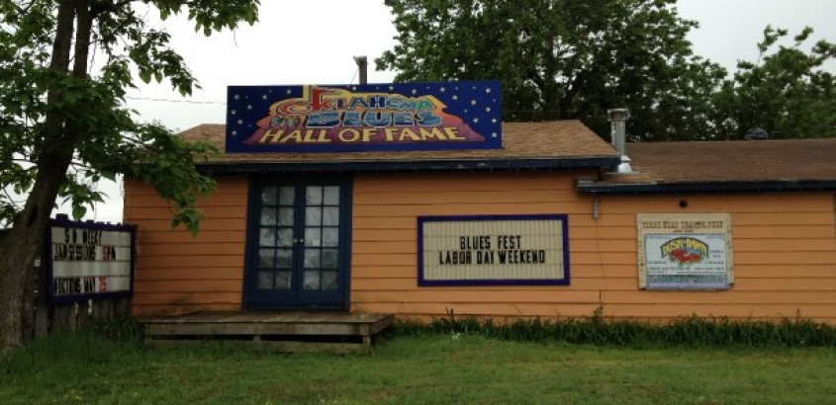

Keeping Oklahoma Blues Alive
Share this article and spread the love.
Join the conversation! Post a comment on this article.
Keeping Oklahoma Blues Alive
Filed by Michael Cross in Art & Life, Feature, Local News, News.
July 19, 2013
Click here to download audio
The Blues: When most people hear it they think of Memphis or Chicago or New Orleans even Kansas City.
But, there’s a resurgence of the blues in Oklahoma focusing on the present as well as the past.
Just off I-40 and Highway 69 north of Checotah sits the small town of Rentiesville.
The historic black town of just 99 people includes the Oklahoma Blues Hall of Fame in an old bar which opened in 1936.
The current owner Selby MInner gives us a tour of the place originally opened by the grandmother of blues great D.C. Minner, Selby’s husband.
A display on one wall holds pictures of the 71 inductees to the Hall of Fame over the past ten years.
Although D.C. died in 2008, Selby has kept the hall of fame going as well as the annual Dusk till Dawn Festival which has been around for the past 23 years during Labor Day Weekend.
Oklahoma blues musicians have played with legends like Count Bassie, Duke Ellington, Louis Armstrong, Cab Calloway and Billie Holliday.
And many Oklahomans have become legends themselves like Charlie Christian, Jimmy Rushing, Jimmy Liggins, Lowell Fulson, Roy Milton, Elvin Bishop, and Jimmy Nolen.
So, why doesn’t Oklahoma Blues get the respect it deserves?
Selby’s got a few theories.
“Number one we don’t have the PR that other states have in general. Because this is such a diverse state there’s 11 different topographies here there are people here from all over the nation. It was settled by people and it was never supposed to be a state, so we got a late start.”
But, Larry O’Dell with the Oklahoma Historical Society says the mix of cultures makes Oklahoma Blues Special.
“You had American Indian, you had African American, but the white population from the north and land runs they came from Kansas and then southerners came up from Texas and Arkansas so you kind of have a line across Oklahoma where in that you have all these different people mingling which is all kinds of different music and I think that’s one reason why Oklahoma has such a different music tradition.”
In fact, Oklahoma City musician and band leader Hart Wand published the first blues song on Sheet music called “Dallas Blues”.
At her home in Oklahoma City, Dorothy Ellis also known as Miss Blues plays a version of it on her computer.
For 70 years Miss Blues has performed what she calls a style of music unique to America and Oklahoma.
“I think that we should celebrate just because it’s there and it’s the one thing that we can call our own in America. What else we got that nobody else’s hand hasn’t been in.”
Miss Blues started singing the Blues when she was eight years old and has always believed is started in Oklahoma.
She was inducted into the Hall of Fame in Rentiesville back in 2004.
She says she loves the fact that the hall of fame is in an old drinking establishment.
“It’s in a juke joint,” she laughs. “Everybody else got a real pretty place. We got this juke joint and it’s housed in where the blues started in a juke joint.”
Another theory on why Oklahoma doesn’t get the respect it deserves for its contribution to Blues is a lack of an established music scene like Memphis.
But a local group, Watermelon Slim and the Workers wants to change that.
Norman resident and Bassist Cliff Belcher says the band recently returned from a festival in Finland and the last four albums have received worldwide attention.
“You know, we recorded all four of these albums that we have so far 16 nominations and one album of the year and band of the year for the 2008 blues music awards that was all recorded right here in Norman, Oklahoma.”
Watermelon Slim, Miss Blues and Selby Minner are all performing over the three day Labor Day Weekend Dusk till Dawn Festival in Rentiesville.
Selby says it’s a family friendly event showcasing true Oklahoma Blues at its roots.
“You didn’t get on this festival unless you were really doing blues. This is kind of an alternative festival because it’s really more about the blues tradition from this region then about the hottest new act out on the circuit because I don’t have the money to get them anyway.”
Several other groups are working to bring Blues back at the end of August with the Mayor’s Blues Festival in Medicine Park and Arcadia’s Blues Festival.
There’s also a free event on Blues culture in our state at the Oklahoma History Center on August 28th.
