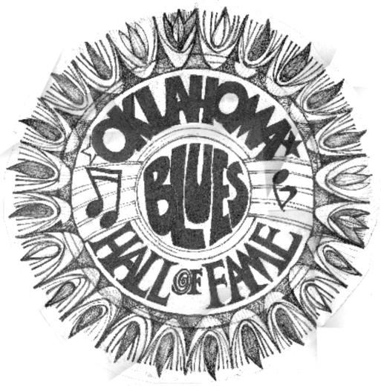
OBHOF INDUCTEES 2104 Why We HonorThem:
Dr. Harold Aldridge March 3, 2014

Aldridge sings the blues
Dr. Harold Aldridge is a retired professor of psychology at NSU in Tahlequah.
Tahlequah Daily Press
By RENEE FITE Special Writer
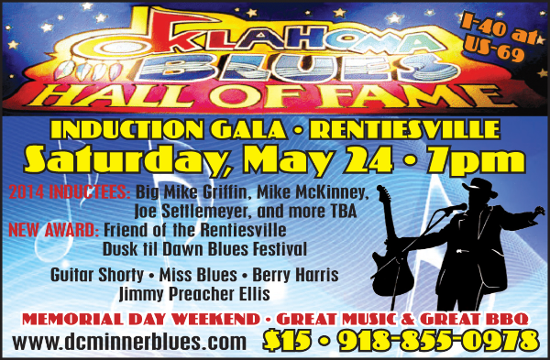
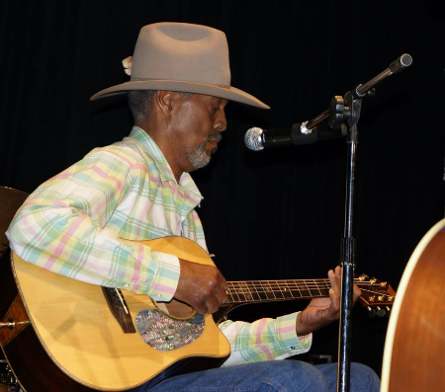
TAHLEQUAH — The gray is beginning to cover his once-black hair, and it shows when the tall, lanky musician adjusts his black felt cowboy hat.
He’s admits to being a little nervous. To keep his hands busy and mind occupied before the show begins, he tunes his guitar, glancing around the room, waving or nodding to friends.
“An Evening of Blues Music,” presented at Webb Tower by Dr. Harold Aldridge, professor emeritus of psychology at Northeastern State University, was in observance of Black History month.
After a brief introduction and enthusiastic applause, Aldridge began with a joke.
“As the milk cow said to the dairy man, ‘Thanks for the warm hand,’” he said.
For the next hour, the audience was taken on a journey through black history via the blues, from deep in the Mississippi Delta, to Alabama, the East Coast, Kansas City, Oklahoma, Texas and California.
“I’m going to tell you the history of blues, and hopefully, it will be entertaining,” Aldridge said. “I stick with the old stuff, from Memphis, Mississippi, Alabama, and Tennessee.”
According to Aldridge, blues music is evolving.
“It’s almost like rock in some places; I guess next we’ll have rap blues,” he said.
As his story unfolded, the audience learned the blues has changed with varying locations and situations.
“The blues originated in West Africa and came here as a feeling, the soul of it, the spirit of high John the Conqueror,” said the Aldridge. “Guitars and banjos came, too.”
Aldridge said his dad sang the old blues songs, and his granddad told stories, as did his aunties, of their history and growing up in the black community of Taft. He also learned all styles of blues as he played guitar with friends of his father, some of the old men around town.
“When the slaves worked in the fields doing the same thing every day, they sang out field hollers and chants that built on one another,” said Aldridge. “Along with work songs, spirituals and gospel, they developed into the blues.”
Through the songs, they would built one another up, he said.
His grandfather worked for Midland Valley Railroad in Muskogee from 1920 to 1945.
“He was a gandy dancer, part of a crew of six men who built the railroad track with a pick and an ax,” Aldridge said. “They unloaded gravel by hand, then carried heavy rails and had to line them up. They used the cadence of songs to line it up right.”
Throughout the performance, Aldridge mentioned several blues men, his favorites, then played a song typical of that singer’s style, telling stories about him.
“Robert Johnson’s deep Delta blues opened up the door for other blues musicians. The deep blues of the South reflects life and death, hard work and hard times,” he said. “As blues left Mississippi and Alabama and filtered, it was changed by the music already there. On the east coast, it became Piedmont blues, a softer sound with more picking to it. In the Chicago-style blues of Jimmy Reed, it was a rolling style: simple, basic stuff. The audience knew his songs and sang along.”
Aldridge related the story of R.A.L. Burnside, who spent time in prison for murder.
“He denied killing anyone, saying, ‘I did mean to shoot the guy in the head, but his dying was between him and God,’” said Aldridge. “These guys were a different breed of cats.”
In Texas, they played a single note, picking blues-style. When blues made it to the West Coast, it had more of a jazz style – like T-Bone Walker, from whom Chuck Berry got his moves.
“Oklahoma was a crossroads from Kansas City, to Texas and California,” he said. “How did blues get to Oklahoma? There were blacks who came in shackles with the Five Civilized Tribes, and after the Civil War, tribes were in flux. And there were Freedmen.”
The tribes tried to make the territory an Indian state.
“But ‘the Man’ saw too many resources for that to happen, he said. “State negroes, born in the U.S., came to Oklahoma territory because it was supposed to be a free state. They were just gamblers enough to believe it would be an open free state.”
With the Dawes Commission, many freedmen got land, the same as Indians.
“Former slaves and Indians knew nothing about owning little parcels of land; they believed all the land was open and so the land got away from them real quick,” said Aldridge.
More family stories followed, including a song written for his grandfather, Buddy Wells, who was a quadroon: a quarter black and three-quarters white. Wells was raised under the tutelage of his white father.
His aunties said when the father died, the whites considered Buddy to be “uppity” when he wouldn’t stay in his place, so he left ahead of a mob and set up a home in Taft.
Blues songs are born from coping with such situations.
“I’m going to sing a song about race, money, politics and sex,” Aldridge said, “So if you don’t like one part of the song, hold on to it and I’ll get to something you’ll like.”
Inviting the standing-room-only audience to sing the chorus, he sang, “I had the blues so bad one time; it put my face in a permanent frown; now, I’m feelin’ so much better; I could cakewalk into town.”
And like many a blues song, the evening ended with hope and humor.
Ben Kracht, chair of the Cherokee and Indigenous Studies, and the NSU History Department, sponsored the event.
“I’ve always been a fan of blues music,” Kracht said.
“Harold knows the history of the songs and the stories that go with it.”
Carl Farinelli, musician and professor, said he shows a video of Aldridge to his American Song as Literature class.
“He knows, and takes you back to the roots of the blues from work hollers – rhythms built on work that the poorest folk did in those days,” Farinelli said. “He takes you down a historical blues road. Very few people know that road the way Harold does.”
Mike McKinney
Son of the great Oklahoma City pianist /educator we inducted last year, June McKinney, and “Road bassist for the Jacksons (recommended by Nate Watts). Credited on the Jacksons album Triumph [Epic, 1980], and is the bassist heard on Jacksons: Live [Epic, 1981].” Mike was playing a five string bass when it was still a novelty and has been around the world on tour twice with Michael Jackson.

Big Mike Griffin
Big Mike Griffin grew up in southern Oklahoma, where he was introduced to music at an early age. " My Dad played so there was always a guitar or fiddle laying around the house. It seems like I've been playing as long as I've been alive." Later, he began listening to blues artists like T-Bone Walker, Paul Butterfield, and Mike Bloomfield. His blues education was further enhanced by late night highway trips to Texas to catch legends like Freddie King, Albert King, and Albert Collins.
When the economy faltered in Oklahoma, Griffin set out for Nashville where he began playing wherever he could while finding players along the way who would make up the nucleus of the Unknown Blues Band. As their popularity grew, the band began to appear in front of larger audiences and to perform at such prestigious festivals as the King Biscuit Blues Festival and the W.C. Handy Festival. They also expanded their regular touring schedule, travelled to the East Coast and then out West.
In 1992 his Back on the Streets Again debut served to further advance the band which was on the road to building a reputation as an original blues ensemble. They have appeared with such great names as Ray Charles, Lonnie Mack, and Clarence "Gatemouth" Brown.
In 1993, Gimme What I Got Comin' brought the band further acclaim as a solid force on the blues scene. The album grabbed the attention of blues fans, critics, and DJs and snagged a high-ranking spot on Living Blues Magazine's national radio chart.
Fifth of Whiskey, Case of the Blues, a song from the album, was nominated as Song Of The Year for the 1994 W.C. Handy Awards.
Major touring dates on both U.S. coasts and Canada, as well as Europe, served as a catalyst to broaden the fan base for the band. Griffin also played on the month-long "Malaco Europe '93" musical extravaganza, where he shared the stage with legends like Little Milton, Denise LaSalle, and Latimore. He then worked with Artie "Blues Boy" White, laying down tracks for his "Different Shades of Blue" release, as well as providing explosive guitar work on James Peterson's "Don't Let The Devil Ride" album.
In 1996 came his third release, Sittin' Here With Nothing, a refreshingly contemporary approach to the time-honored tradition of the blues. From start to finish, it captures the incredible power of Mike Griffin's brilliant guitar work, smoky vocals and finely tuned songwriting talents.
"He plays a Les Paul guitar, but it looks like a ukulele in his hands," says Claypool, who also is on the board of directors of the Beale Street Blues Society. "We've been trying for a long time to find him a T-shirt big enough to put the Blues Society logo on. I know he wears a 5X shirt. "He's a good guitarist, and he's got a good voice," Claypool says. "And of course, he's got that great stage presence."
Sittin' Here With Nothing features five original compositions, a couple of Little Milton Campbell songs and a few others from the Waldoxy publishing arm. Griffin receives great backup from the Unknown Blues Band, which features Clayton Ivey on piano and Hammond organ, David Hood on bass and Memphian Pat O'Connor on drums.
In 1997 Griffin started thinking about the fascinating idea of recording an album just for Harley Davidson fans. He always wanted to do a biker's project, but it was the driving force of his brother and the stimulation of his own gang that finally got the ball rollin'.
Entitled "Harley in the Rain", Griffin recorded a well-balanced mixture of originals and all-time classics like Lowell George's "Willin'" and Alain Toussaint's "Get Out Of My Life Woman". With a no-nonsense production and a strict four piece line-up he offers the 10 numbers in a direct muscular guitar sound that is equally suited to blues, soul, rock and funk. "Harley in the Rain" marks the stunning crossover release of the artist Big Mike Griffin that truly confirms him as a major talent on the current scene.
"Twin Brothers of Different Mothers" is our second release. It features the hard hitting biker anthem "Twin Brothers", and the mournful "Love will never die". One of our biggest sellers!!
"LIVIN' LARGE" is the third release from Chrome Link Records featuring a mix of original and standard blues tunes as well as a few surprises. Buddy Miles( Jimmy Hendrix, the Electric Flag, Buddy Miles Express) makes a guest appearance on "Down in Hollywood", "Blues for Mr. B" and the Albert King standard "Pretty Woman".
"Live at the Full Moon Saloon" is the live show that was recorded during Bike Week. Includes the hits "Cool Guitar" and "I'd Rather Go Blind" Power trio on steroids!! One of our best sellers.
"Two Lane Road" takes a look back at Big Mike's Oklahoma roots. "Two Lane road" and "The 62" are based on true events and give a nod to the wild west that Big Mike grew up in. Freddie Kings "Pack it up" is the stellar cut that features Killer guitar and rythm section featuring Funk Brothers bassist Bob Babbitt.
"All My Runnin'" is Big Mikes latest release featuring the title cut written by Big Mike's childhood friend, Byrd Taulbee. "Iron City Blues" and "Shoal Creek" is featured from the soundtrack of the award-winning documetary "Iron City Blues". A "must have" for Big Mike fans!!

"Iron City Blues" is the award-winning documetary featuring Big Mike as well as an original soundtrack written by Griffin. Blues music and a lawless Tennesee town. Does it get any better than that? You better watch your back!!!! 60 minutes and a bonus Soundtrack CD included.

Joe Settlemires

A Texas Playboy you may ask – and rightfully so- but yes. Bob Wills band always played a lot of blues, and they went to Greenwood to jam sessions many times. Their theme song was Milk Cow Blues. And Joe has not forgotten his blues , lately you will see him in the band of Dorothy Miss Blues Ellis playing those blues – with great finesse. We want to honor his commitment to the guitar as well. He is a consummate player.
The Youngest Texas Playboy returns!
From the Bob Wills Website, Turkey Texas --- March 21, 2014
The youngest Texas Playboy returns, Joe Settlemires, a long time friend of Turkey, Texas will be returning to Bob Wills again this year. You can enjoy his music and talent at the Thursday and Friday night dances and the outdoor concert as he joins his fellow Playboys and Western Swing enthusiasts.
Joe Settlemires is one of Oklahomas most prolific and celebrated musicians. Joe began playing guitar professionally at the age of 14. He landed one of country musics most prestigious gigs, playing with the legendary Bob Wills and the Texas Playboys, at the age of 19 when regular guitarist Tag Lambert fell ill with pneumonia and couldn't go out on the road. At Lamberts suggestion, the Playboys tour bus rolled into Guthrie to pick up the young string slinger and the rest, as they say, is history as Settlemires became known as The Youngest Texas Playboy.
In the years that followed, Settlemires played with a Who's Who of country music legends including Willie Nelson, Loretta Lynn, Red Foley, Tex Ritter, Harold Bradley and others. He also backed up performers in the popular and jazz genres like Bob Hope, Howard Roberts and Pat Martino as well as performing with the Oklahoma City Symphony.
Though he is well known for his technical prowess on the guitar, Joe is complete musician, having written arrangements for thousands of songs and passed his musical legacy along to hundreds of aspiring guitar players down through the years through private instruction. Settlemires students have gone on to play with musicians and groups like Merle Haggard, George Strait, Neil Diamond, Restless Heart, the Judds, Charlie Hall, Hayes Carll and others.
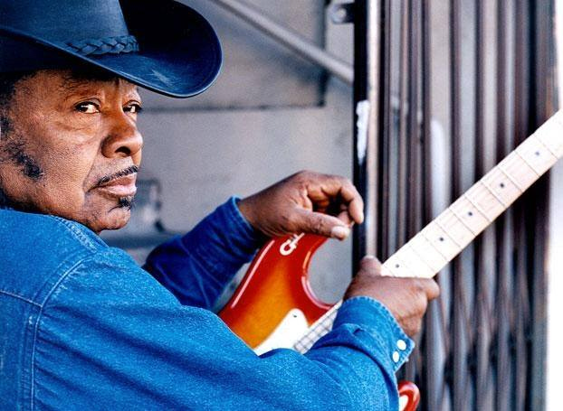
Settlemires unmistakable contribution to American music has been recognized by four halls of fame and in 2006, the Oklahoma State Legislature recognized him for his 50 years of contribution and dedication to both the Oklahoma music industry and music education in the private and public sector.
Guitar Shorty
has played here many times at a price we could afford – thanks Shorty!!
Currently nominated for two Blues Music Awards by the Blues Foundation in Memphis!
Guitar Shorty, aka David Kearney, was born in Houston, Texas but raised in Kissimee, Florida. As a young boy he would sneak into his uncle’s room and try to play his guitar. He was so small his hands didn’t fit around it’s neck, so he would lean it against the wall and play it like a stand up bass.
When other kids were in high school, Shorty was a student by day and a working musician by night. One evening when he went to work the marquis read, “The Walter Johnson Band featuring Guitar Shorty"; the name he would go by from then on was born.
Right out of high school at the age of 16 Shorty joined Ray Charles and his band for a year. At the age of 17 he recorded a single under the direction of Willie Dixon on the Cobra label. When Shorty was lured away to play with Guitar Slim he moved to New Orleans.
In New Orleans, Shorty fronted his own group that became the house band at the legendary Dew Drop Inn. There he played with greats such as T Bone Walker, Big Joe Turner and Little Richard. It took a job with Sam Cooke to get 19 year old Shorty on the bus and on his way to the West Coast.
Shorty lived and worked in both Los Angeles and Canada until in 1961 he met his wife, Marcia, in Seattle. When Shorty married Marcia he also got Jimi Hendrix, Marcia’s brother for a brother-in-law. The young Jimi Hendrix came to see Shorty play often and they were friends until Jimi’s untimely death
Like a Texas tumbleweed, Shorty rolled back to the Los Angeles area in 1971 and Los Angeles has remained his home. He cut his first full album and got his first W.C. Handy Award while living there.
Since that time Shorty has recorded several albums for the Black Top label and is currently signed to Evidence Records. He often jams at local clubs with former members of the Eagles, Steely Dan, and calls local blues artist Keb Mo a personal friend and fan. He continues to capture audiences with his sincerity, energy, and Rocking/Blues style. - Nov.2001

History Through Music event discusses the evolution of the blues
Story by Darla Shelden on August 13, 2013 . Click on author name to view all articles by this author. You can follow any responses to this entry through the RSS 2.0. Both comments and pings are currently closed.
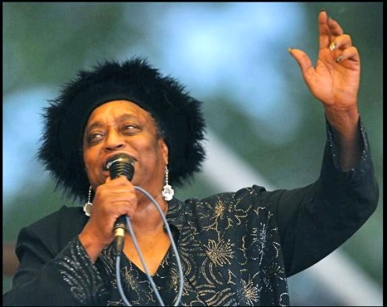
Blues legend Dorothy Ellis, aka “Miss Blues” will present an educational performance on the development of Blues music on Aug. 29 at the Oklahoma Historical Society’s History through Music event co-hosted by the Oklahoma Humanities Council. Photo provided.
By Darla Shelden
City Sentinel Reporter
Accomplished blues singer and guitar player, Dr. Harold Aldridge and the legendary Dorothy Ellis, aka “Miss Blues” are special guests for the next edition of the History Through Music program themed, “Oklahoma Blues.” They will present an educational performance on the development of Blues music.
This fascinating program will take place on Thursday, Aug. 29 at the Oklahoma History Center at 800 Nazih Zuhdi Drive. It is located just East of the State Capitol on N.E. 23 St. in Oklahoma City. Doors will open at 6 p.m. and the program will begin at 7 p.m.
History Through Music is a partnership between the Oklahoma Humanities Council and the Oklahoma Historical Society.
Born and raised in the small, all-black town of Taft, Oklahoma, Dr. Aldridge learned from the town’s older musicians how to play the guitar. He will perform and tell the history of the differing styles of Blues, including how regional sounds emerged.
A retired professor of psychology from Northeastern State University, in Tahlequah, Aldridge is a regular act at the Dusk till Dawn Blues Festival. The event takes place in Rentiesville, Oklahoma, Aug. 30 through Sept. 2.
Dorothy Ellis, born Dorothy Choncie Ellis on a Texas cotton plantation, began shouting the Blues in the 1940s. Ellis came to Oklahoma City, alone, at the age of thirteen.
In 1954, she sang with a band called the Rockin’ Aces, which featured Little Eddie Taylor. Ellis later attended Oscar Rose Junior College in Oklahoma City, and went on to earn a master’s degree at the University of Central Oklahoma.
A 2004 Oklahoma Blues Hall of Fame inductee, Ellis has performed at some of the historic venues of Oklahoma City’s Deep Deuce district.
International Blues Artist Taj Mahal calls Miss Blues “the Blues Babe of all Blues Babes.”
Miss Blues will share some of her story, and explain her Texas Shout style of Blues. She will also be appearing at the Dusk till Dawn Blues Festival.
“The event is a great opportunity to not only learn some history of the Blues as it developed in America and Oklahoma, but also to hear some very talented Blues music,” said Larry O’Dell, OHC, Director of Special Projects/Development.
“Dr. Aldridge will start with the beginnings of this music style and take it to its 20th century popularity,” said O-Dell. “Miss Blues, or Dorothy Ellis, will perform the “Texas Shout” Blues that she learned as a child in the early 1940s in north Texas.”
Through the humanities discipline of history, Aldridge and Ellis will perform the different Blues styles and lecture on their roots. They will each also explain regional differences and the migration of these styles into Oklahoma.
During the program scholars will discuss how the unique settlement of the Sooner state mixed different cultures and music, creating its own distinctive sounds and musicians.
Ellis and Aldridge will examine the influence that Oklahoma’s all-black towns and their Juke Joints had in the evolution of the regions music and talk about the roles that secular and gospel music played.
Before the concert, there will be a presentation about other notable blues musicians with ties to Oklahoma including Funny Papa Smith, Jimmy Rushing, Jay McShann, Jimmy Liggins, Joe Liggins, Lowell Fulson, Roy Milton, Ernie Fields, DC Minner, Elvin Bishop, and Jimmy Nolen.
Oklahoma Historical Society members can RSVP and receive free seats. Non-members may purchase an OHS family membership at half price, $25.00, or any of the other membership levels at regular price, and RSVP for up to two seats.
The family membership is a one-year membership that includes free admission for the member and family with a maximum of 12 family members per visit to any of the Oklahoma Historical Society’s 31 museums, military sites or historic homes along with other benefits.
The Rentiesville Inductions are sponsored by FOR Blues, Nichols Dollar Saver Groceries, and Leon Rollerson Productions.

OKLAHOMA BLUES HALL OF FAME
CONTACT: 918) 855-0978 dcminner@windstream.net, www.dcminnerblues.com, 701 D.C. Minner St Rentiesville OK 74459 facebook Selby Minner

